How Do Components Work

DOC. No.: | REV.: 0.0 |  |  | PRODUCT:
TITLE: How do components work |  |  |  | Project: | SL 15
Prepared by: | Lewis |  |  | Date: | 2008.10.06
Remark: | Approval:
Remark: |  | Department | Title |  |  | Signature
Remark: | 1 | Electronic R&D
Remark: | 2
Remark: | 3
Remark: | 4

Revision | Description of Change | Author | Date
V 0.0 | Create this document | Lewis Chen | 2008.10.06
V 0.1 | Add air-break, cooling unit, stick dispenser | Lewis Chen | 2008.12.30
V 0.2 | Add Freestanding cup system | Lewis Chen | 2009.7.20
V 0.3 | Add fresh brewer and new ceramic valve | Lewis Chen | 2009.9.27
V0.3 | Add plastic instant boiler | Lewis Chen | 2010.4.6

1. Grinder 5
1.1. Connection 5
1.2. Movement step 5
2. ES Brewer 6
2.1. Connection 6
2.2. Movement step 8
3. Fresh brewer 9
3.1. Movement step 10
4. Boiler 11
4.1. Hot water boiler 11
4.1.1. Connection 11
4.1.2. Movement step 12
4.2. Steam boiler 13
4.2.1. Connection 13
5. Mixer 15
5.1. Connection 16
5.2. Movement step 16
6. Cup Dispenser 17
6.1. SL15 Cup System 17
6.1.1. Brief introduce 17
6.1.2. Connection 18
6.1.3. Movement step 19
6.2. Free Standing Cup System 20
6.2.1. Brief introduce 20
6.2.2. Movement step 22
7. Bean/Sugar/Topping/Cacao Container 23
7.1. Connection 24
7.2. Movement step 25
8. Valve Block 25
8.1. Connection 26
8.2. Movement step 26
9. Air break 27
9.1. Connection 27
9.2. Movement step 28
10. Cooling Unit 29
10.1. Connection 30
10.2. Movement step 31
11. Stick (a new version is coming) 32
11.1. Connection 33
11.2. Movement step 33
12. Ceramic valve 34
12.1. One to six ceramic valve 34
12.1.1. Movement step 34
12.2. One to three ceramic valve 35
12.2.1. Movement step 35
13. Plastic Instant boiler 36
14. To be continue 36
14.1. Objective 36
14.2. Scope 36
14.3. Reference 36
14.4. Abbreviations 36
14.4.1. heading3 36
Appendix 36
Appendix 37

Grinder
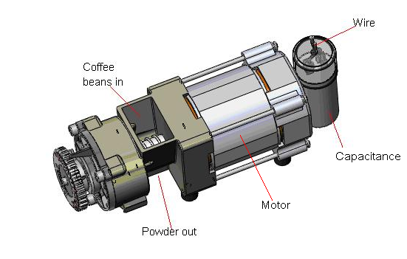
Function: Use to grind coffee beans
Electronic part: 1 motor
Ground ability: 3.7g/second
Normal voltage: 220V

Connection
Output

Component  Board ID |  | Grinder1 | Grinder2
75466 | IC | U903 Q1(left) | U903 Q5(right)
75466 | Connector | J901 PIN1 | J901 PIN5
75468 | IC | U402 Q4 | U402 Q5
75468 | Connector | J902 PIN7 | J902 PIN8

Movement step

Let coffee beans in
Start motor

ES Brewer
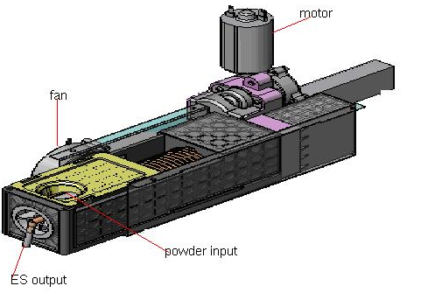
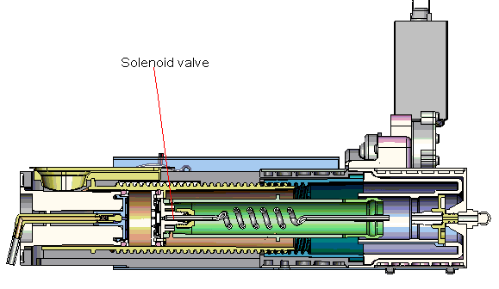
Function: Brew espresso beverage
Electronic part： 1 motor、2 hall sensor
Capacity range: 5g-12g
Cycle time: 55s (Old value, this value keep changing)

Connection
Output
Component part  Board ID |  | Brewer | Fan
75466 | IC
75466 | Connector
75468 | IC | U201 Q2(N) and U202 Q2(P)  [Brewer_COM]  U201 Q1 (N) and U202 Q1 (P) [Brewer] | U201 Q0  (Brewer blower)
75468 | Connector | J202 PIN4(Brewer) and PIN8(Brewer_COM) | J202 PIN5

Input
Component part  Board ID |  | Brewer | Fan
75466 | IC
75466 | Connector
75468 | IC | Sensor  U804 IN2  [home sensor(Brewer position FB)]  U804 IN1  [dosage sensor(Brewer step FB)]  Motor  U804 IN8(Brewer COM FB) | U804 IN3  (Brewer blower FB)
75468 | Connector | Sensor  J202 PIN1[dosage sensor(Brewer step FB)]  J202 PIN2[home sensor(Brewer position FB)]

Movement step
Reset the brewer, cylinder moves to home position
(Home sensor)
Cylinder moves to dosage position
(Dosage sensor)
Presses powder into cake (motor)
Wait for grinder
(Timer)

Prepare about 10% hot water
(Solenoid valve)
Idle with 1-2 second
(Timer)
Re-press cake
(Current)
Total brewing
(Solenoid valve)
Open solenoid valve and press cake again (exit spare water, make sure cylinder clean)
Cylinder and piston move back
(Home sensor)
Cylinder move forward a little bit
(Timer)
Move back to home position, then open release valve
(Home sensor,release valve)
Open brewer blower
(U804 IN3)

Fresh brewer
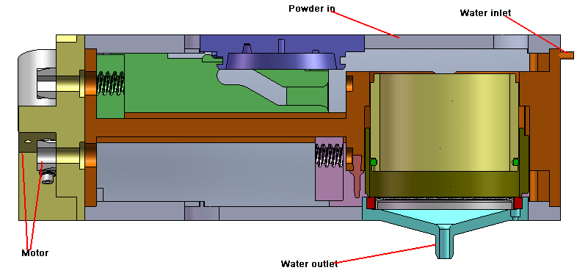

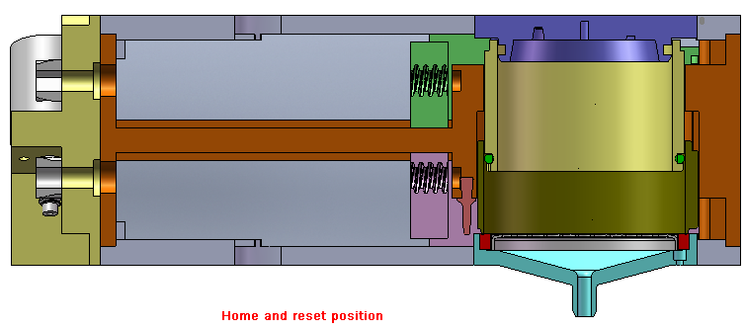

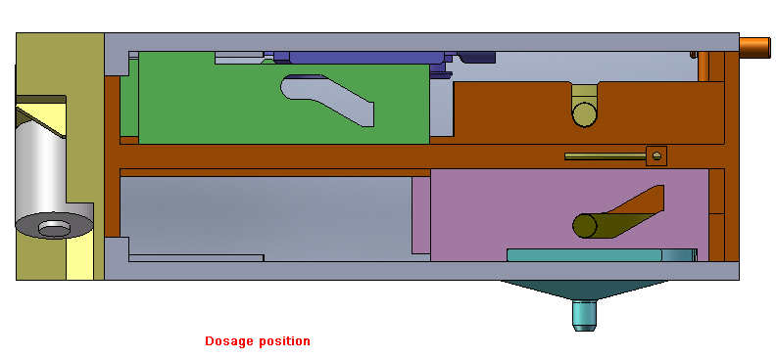

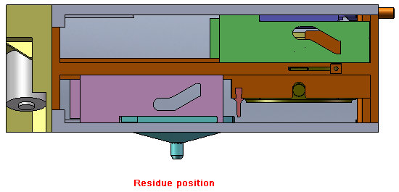Function: Brew tea and instant coffee
Electronic part： 2 motors
Capacity range: 9g
Cycle time: Not define (keep changing)

Movement step
Move to reset position (Upper chest motor and lower chest motor)
Change to dosage mode (Upper chest motor)
Presses powder into cake (upper chest motor)
Wait for canister

Prepare about 20% hot water (valve)
Idle with 1-2 second (Timer)
Total brewing
Move to residue position, and then scrape the residue (lower motor)

Move back to home position (Upper chest motor)

Boiler

Hot water boiler
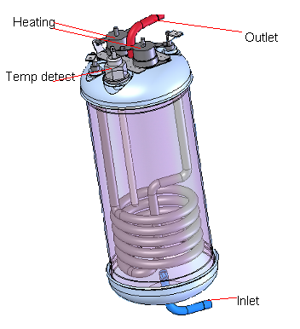
Function: Provide hot water to brewer the coffee and the steam boiler
Capacity: 700ml
Off temperature: 118℃
Outlet temperature: 90℃ (instant), 99℃ (espresso)
Power: 1200w
Electronic control part:
1 NTC sensor, 2 wire to control on and off of the boiler

Connection
Output
Component part  Board ID |  | Heating | Sensor (temperature detect)
75466 | IC
75466 | Connector
75468 | IC | U302 Q4  (Control boiler)
75468 | Connector | J901 PIN3  (Low voltage start to boil water)

Input
Component part  Board ID |  | Heating | Sensor (temperature detect)
75466 | IC
75466 | Connector
75468 | IC | Boiler feedback:  U801 IN14  (Low voltage means something is wrong with power supply of the boiler) | U801 IN4 (ADC convert use)
75468 | Connector | Boiler feedback:  J901 PIN6 | J302 PIN7

Movement step
Inlet water
Wait until temperature reach
(Sensor)
Start boiler
Stop boiler

Steam boiler
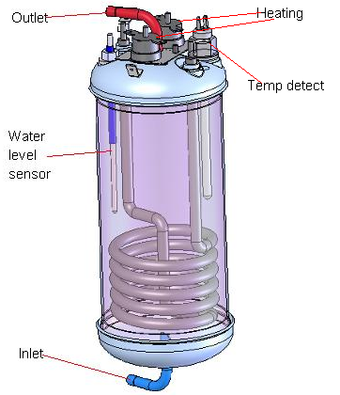
Function: Provide steam to milk froth
Capacity: 700ml
Off temperature: 145℃
Outlet temperature: 123—125°C
Power: 1800w
Electronic control part:
1 NTC sensor, 1 water level sensor, 2 wires to control on and off of the boiler

Connection
Output
Component part  Board ID |  | Heating | Sensor (temperature detect) | Sensor  (water level)
75466 | IC
75466 | Connector
75468 | IC | U901 Q2  (Control boiler)
75468 | Connector | J901 PIN4  (Low voltage start to boil water)

Input
Component part  Board ID |  | Heating | Sensor (temperature detect) | Sensor  (water level)
75466 | IC
75466 | Connector
75468 | IC | U801 IN15  (Low voltage means something is wrong with power supply of the boiler) | U801 IN3 (ADC convert use) | U801 IN5  (Detect water level)
75468 | Connector | J901 PIN7  (boiler feedback) | J302 PIN8 | J302 PIN11

Movement step
Inlet water
Wait until temperature reach
(Sensor)
Start boiler
Stop boiler

Mixer
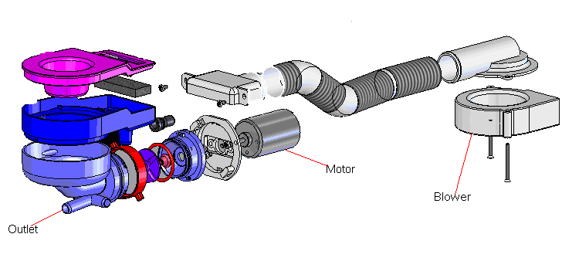
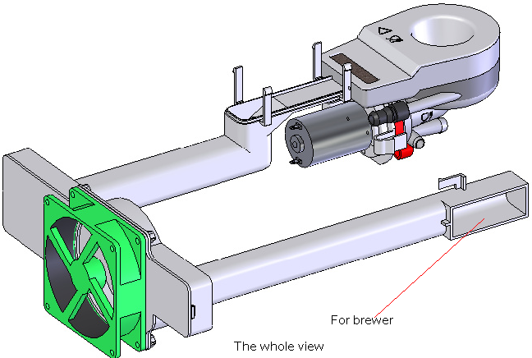

Function: Mix powder, dispensing from canisters, and water, coming from boiler, or coffee, coming from brewer, together to make product obtain some kind of taste
Capacity: 120ml
Cycle time: 12s
Electronic control part: 1 Motor, 1 blower

Connection
Output
Component part  Board ID |  | Mixer motor | Mixer blower
75466 | IC
75466 | Connector
75468 | IC | U401 Q6  (Mixer motor) | U401 Q4  (Mixer blower)
75468 | Connector | J401 PIN4 and 5 | J401 PIN8

Input
Component part  Board ID |  | Mixer motor | Mixer blower
75466 | IC
75466 | Connector
75468 | IC | U804 IN13  (Mixer motor FB) | U804 IN15  (Mixer blower FB)
75468 | Connector

Movement step
Wait for container
Start mixer motor, valve and fan

Cup Dispenser

SL15 Cup System

Brief introduce
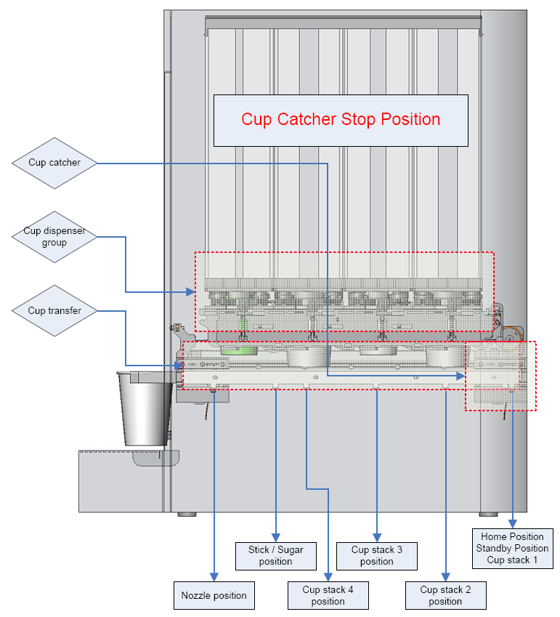

Function: Catch and dispense cups
Electronic control part: 3 Motors (position, catch, dispense), 4 sensors (catch, position, cup detect, cup dispense)

Connection
Output
Component part  Board ID |  | Dispenser motor | Transfer motor | Catcher motor
75466 | IC
75466 | Connector
75468 | IC | U603 Q4 and U602 Q4 | U603 Q5 and U602 Q5 | U603 Q7 and U602 Q7
75468 | Connector
PS: U603 Q6 and U602 Q6 is the public end. (COM)

Input
Component part  Board ID |  | Dispense sensor | Cup detect sensor | Catcher sensor | Position sensor
75466 | IC
75466 | Connector
75468 | IC | U803 IN14 |  | U803 IN15 | U802 IN0
75468 | Connector |  | J602 PIN9  (Link to P2.30 of CPU.) | J602 PIN4 | J602 PIN11
PS:
Dispense sensor: Low means cup dispense successfully.
Cup detect sensor: High means cup existing.
Catcher sensor: Low means one signal comes.
Position sensor: Low means one signal comes.

Movement step
Reset cup system, cup catcher moves to home position
(Position sensor)
Move to proper position of the cup
(Position sensor)
Wait for cup dispense system dispenses a cup
(Dispenser sensor)
Cup catcher move to home position
(Position sensor)

Detect cup
(Cup detect sensor)
Cup catcher move to door
(Position sensor)

Free Standing Cup System

Brief introduce
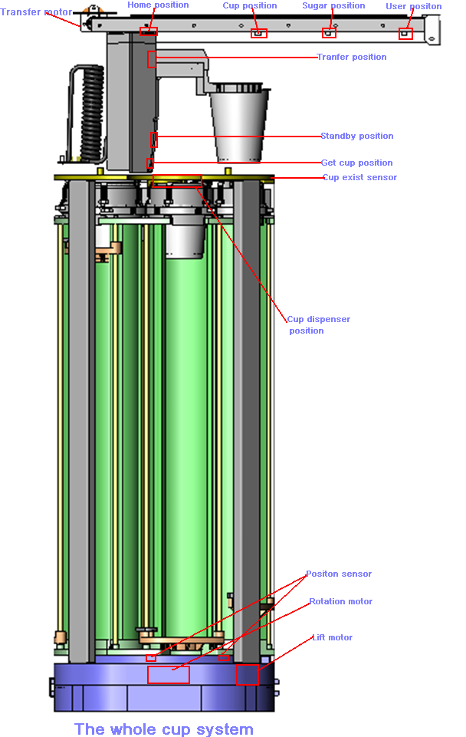
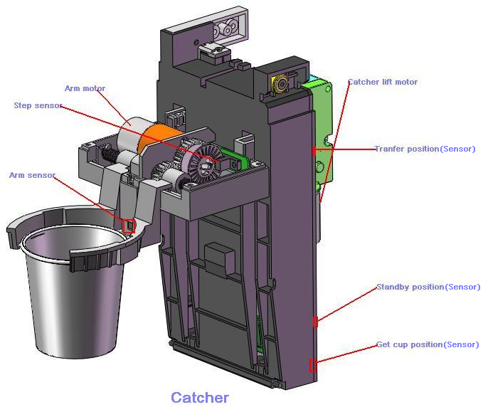Function: Catch and dispense cups
Electronic control part: 5 Motors (1 rotation motor, 1 arm motor, 1 transfer motor,2 lift motors), 8 sensors

Movement step
Reset cup system, cup catcher moves to home position
(Position sensor)
Turn on rotation motor, cup stack move to proper position
(Position sensor, rotation motor)
Turn on lift motor, until a cup have been dispensed successfully
(Cup detect sensor, lift motor)
Cup catcher move to user position (Position sensor)

Move catcher to get-cup position, get a cup.
(Catcher-lift motor, arm motor)
Cup catcher move to transfer position, and then move to sugar position. (Catcher-lift motor, transfer motor)

Bean/Sugar/Topping/Cacao Container
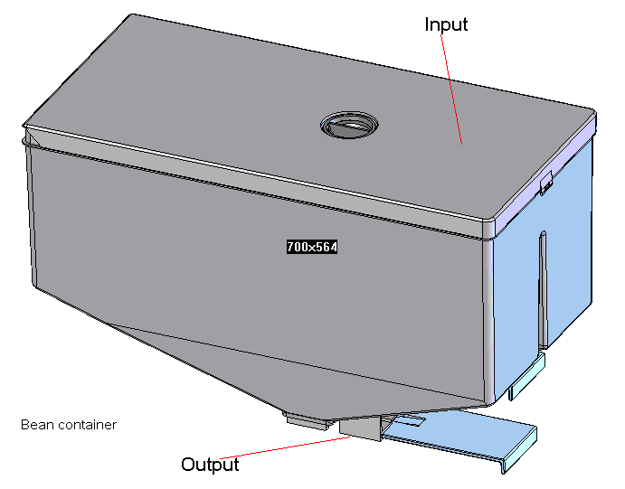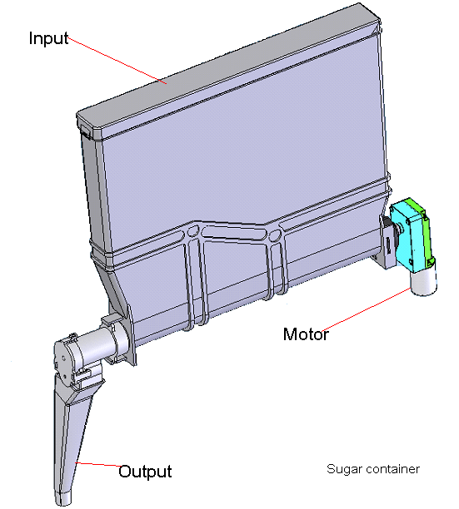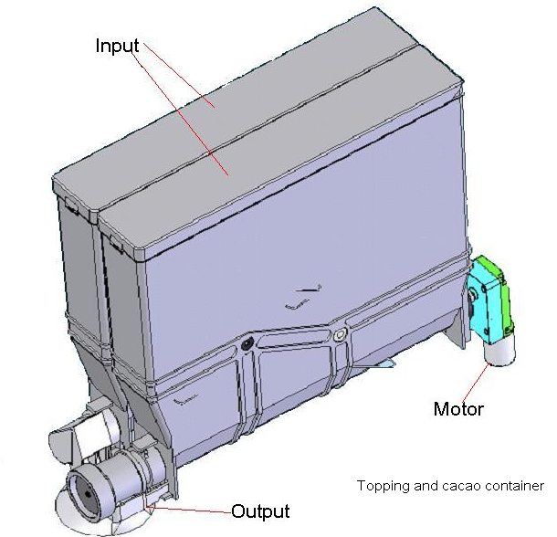

Function: Contain coffee beans/sugar/topping/cacao
Electronic control part: 1 motor (except bean container), and 1 heating unit maybe exist in the feature.

Connection
Output
Component  Board ID |  | Container1 | Contianer2 | Contianer3 | Heating unit
75466 | IC
75466 | Connector
75468 | IC | U401 Q0 (N) and U402 Q0 (P) | U401 Q3 (N) and U402 Q3 (P) | U401 Q1 (N) and U402 Q1 (P) | U401 Q5
75468 | Connector |  |  |  | J401 PIN9
PS: U401 Q2 (N) and U402 Q2 (P) is the public end. (COM)

Input
Component  Board ID |  | Container1 | Contianer2 | Contianer3 | Heating unit
75466 | IC
75466 | Connector
75468 | IC | U804 IN9 | U804 IN12 | U804 IN10 | U804 IN14
75468 | Connector

Movement step
Start motor
Stop motor

Valve Block
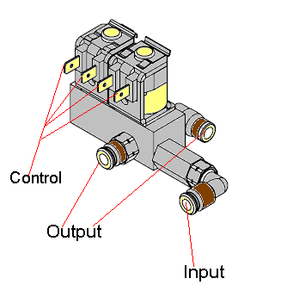
Function: Control hydraulic circuit
Electronic control part: 4 valves

Connection
Output
Component part  Board ID |  | Valve1  (To Esboiler) | Valve2  (To brewer) | Value3  (Mixer) | Valve4  (hot  boiler) | Valve5  (Brewer release)
75466 | IC
75466 | Connector
75468 | IC | U302 Q0 | U302 Q1 | U302 Q2 | U302 Q3 | U302 Q7
75468 | Connector

Input
Component part  Board ID |  | Valve1 | Valve2
75466 | IC
75466 | Connector
75468 | IC | U801 IN8 | U801  IN9
75468 | Connector

Movement step

Open valve
Close valve

Air break
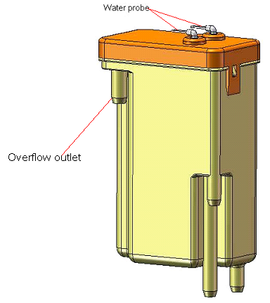
Function: Contain water for use. Gear pump will pump water from it. And gear pump have the ability to pump water without water in itself.
Capacity: 180ml
Electronic control part: 2 water level probe (1 high level probe, 1 low level probe)

Connection
Input
Component part  Board ID |  | Long probe | Short probe
75466 | IC
75466 | Connector
75468 | IC | U801 IN7 | U801 IN6
75468 | Connector

Movement step
Is air break empty? (Long probe)

Open inlet valve
Close inlet valve
Is air break full?
(Short probe)

Y
Y

Cooling Unit
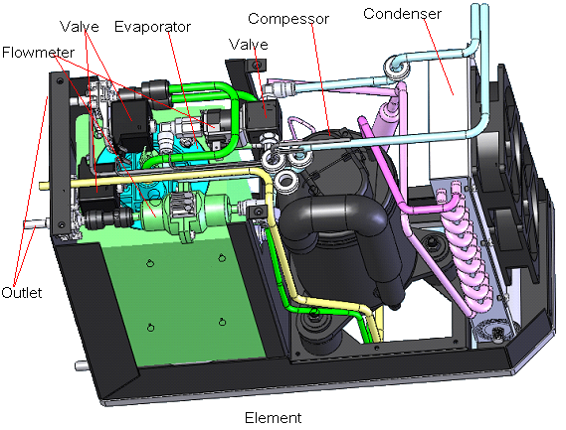

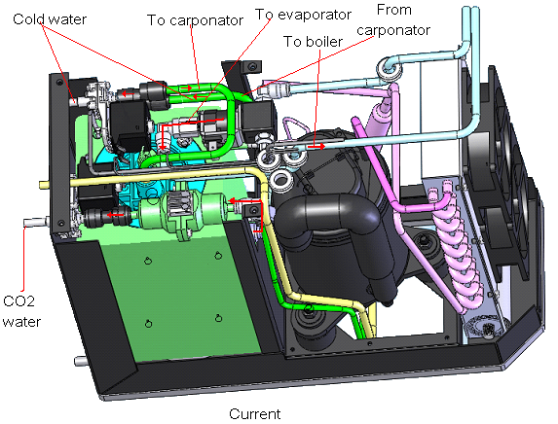

Function: To supply cold drink, include CO2 water and Cold water.
Capacity: 310ml
Electronic control part: Condenser, Compressor, Evaporator (have carbonator in inside), 3 valve, 1 NTC sensor, 2 water sensor, 1 fan

Connection
Output
Component part  Board ID |  | Valve  (Cold water) | Valve  (Soda water) | Valve (Diverter) | Fan  (compressor Fan)
75466 | IC
75466 | Connector
75468 | IC | U602 Q3 | U602 Q1 | U302 Q6 | U602 Q2
75468 | Connector | J501 PIN5 | J501 PIN13 | J301 PIN2 | J501 PIN6

Component part  Board ID |  | Compressor
75466 | IC
75466 | Connector
75468 | IC | U403 Q7
75468 | Connector | J902 PIN3

Input
Component part  Board ID |  | NTC sensor | Water sensor  (low level) | Water sensor (High level) | compressor fan
75466 | IC
75466 | Connector
75468 | IC | U803 IN3 | U803 IN6 |  | U803 IN8
75468 | Connector | J501 PIN7 | J501 PIN9

Movement step
Open DC fan
Start water pump
Low level<water<high level

Start compressor
Y
N
Water reaches high level?

Stop water pump, start compressor
Y
MIN<Temperature<MAX

Open cold water valve or soda water valve
Water>high level
Y
N
Y
Temp<MIN
N
N
Y
MIN<Temp<MAX

Y

Stick (a new version is coming)
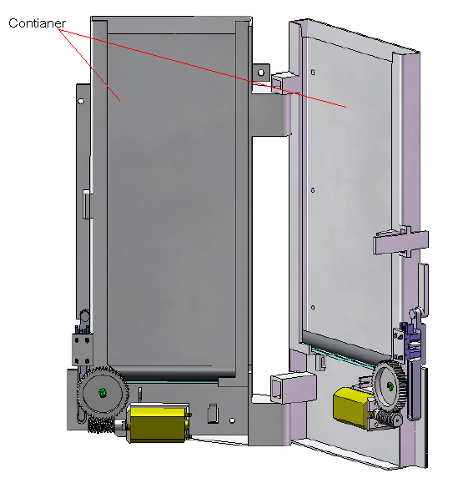
Function: To deliver sticks.
Capacity: will be defined later.
Electronic control part: 2 motors, 2 sensors.

Connection
Output
Component part  Board ID |  | Long stick | Short stick
1 75466 | IC
1 75466 | Connector
75468 | IC | U303 Q6(N)  U901 Q6(P) | U303 Q5(N)  U901 Q5(P)
75468 | Connector | J703 PIN2 | J703 PIN3

Input
Component part  Board ID |  | Long stick FB(motor) | Short stick FB(motor) | Long stick FB(sensor) | Short stick FB(sensor)
75466 | IC
75466 | Connector
75468 | IC | U802 IN3 | U802 IN4 | U802 IN6 | U802 IN7

Movement step
Move motor drop a stick
Stick sensor give out a signal
Stick drops successful?

Y
N
Dispenser timeout

Ceramic valve

One to six ceramic valve
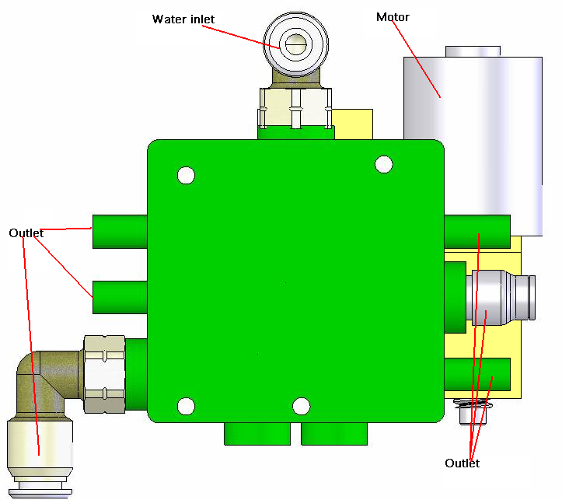

Function: Control water.
Electronic control part: 1 motors, 1 sensor.

Movement step
Move to certain position
Stop motor, wait for water dispense finishing
Move to stop position

One to three ceramic valve
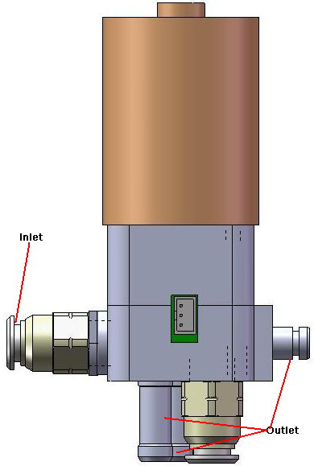

Function: Control water.
Electronic control part: 1 motors, 1 sensor.

Movement step
Move to certain position
Stop motor, wait for water dispense finishing
Move to stop position

Plastic Instant boiler
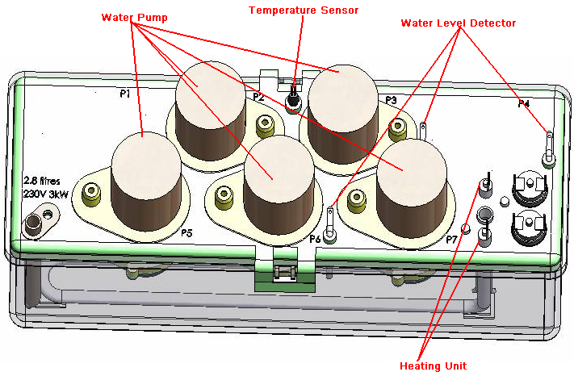
Function: heat water and pump the water out.
Electronic control part: 1-7 pump, 1 NTC sensor, 2 water level detectors.

To be continue

Objective

Scope

Reference

Abbreviations

heading3
Normal

Appendix
Normal

Appendix

